

Department of Electronic and Telecommunication Engineering

University Of Moratuwa

Project: Retinal Blood Vessel Segmentation

|  |  |
| --- | --- |
| Index No. | Name |
| 200123H | A.P.N. Dhanomika |
| 200702H | P.D.G.U.M.B. Weerasinghe |

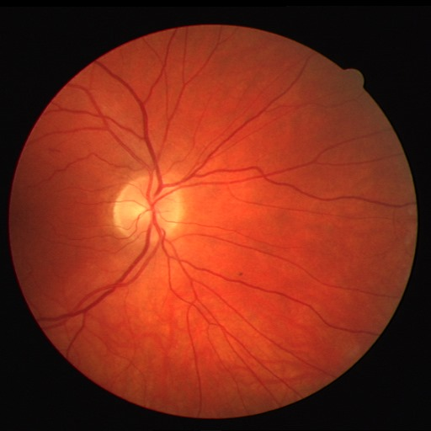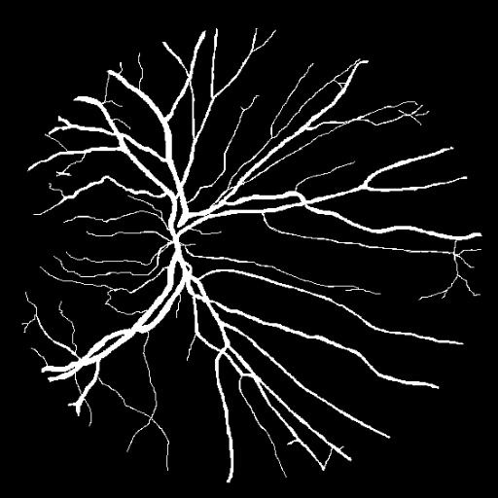

**Abstract**

Retinal vessel segmentation is a critical problem in the field of medical image processing, where the goal is to automatically identify and segment blood vessels in retinal images. This task is essential for early diagnosis and monitoring of various eye diseases, as changes in the appearance of retinal vessels often indicate underlying conditions. This report presents a comprehensive solution for retinal vessel segmentation, leveraging both traditional image processing techniques and deep learning methodologies, to provide a robust and accurate way to segment retinal vessels.

## Introduction

Retinal vessel segmentation is a fundamental step in computer-aided diagnosis for eye diseases, as it allows for the precise delineation of blood vessels in retinal images. The process involves segmenting retinal vessels from the background, which is a complex task due to the varying vessel widths, curvatures, and the presence of noise in the images. Automated retinal vessel segmentation can assist healthcare professionals in diagnosing and monitoring eye conditions efficiently, potentially leading to earlier intervention and improved patient outcomes.

## Related Work

A variety of techniques have been explored for retinal vessel segmentation, ranging from classical image processing methods to the adoption of deep learning approaches. Traditional methods often rely on handcrafted feature engineering, filtering, and thresholding, but they may struggle with the complexity and variability of retinal images. In contrast, deep learning models, particularly convolutional neural networks (CNNs), have demonstrated their potential in retinal vessel segmentation. These networks, such as U-Net, UNet++, and DeepLab, utilize learned features and hierarchical representations to achieve state-of-the-art results, capturing both global and local contextual information.

## Method

### Data Preparation

The project commences with a data preprocessing stage, where the original retinal images are loaded, and their corresponding vessel masks are extracted. To enhance the model's robustness and generalization capabilities, data augmentation techniques are employed. These techniques include horizontal flips, vertical flips, and rotations, leading to the creation of an augmented dataset. The augmented data is saved for subsequent training and evaluation.

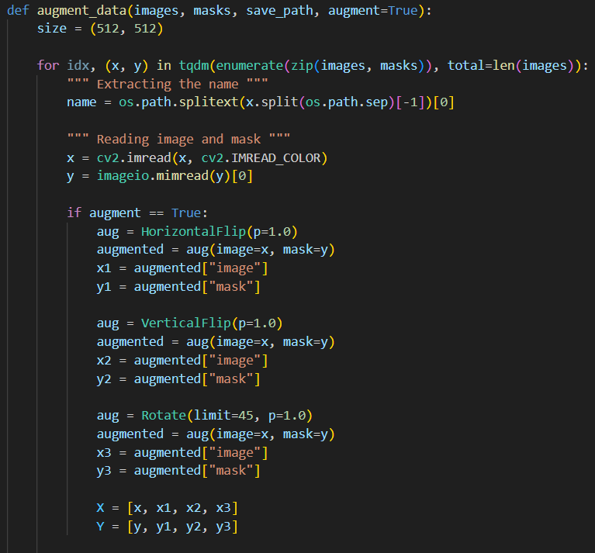 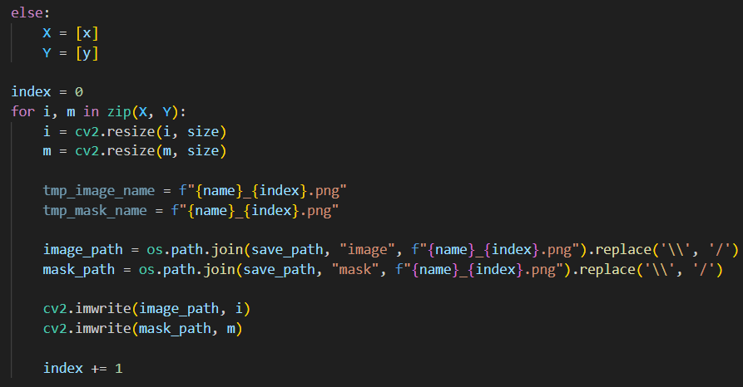

### Model Architecture

At the heart of this solution lies a U-Net architecture, a proven choice for image segmentation tasks. The U-Net consists of an encoder-decoder structure, with the encoder extracting relevant features from the input image and the decoder producing a pixel-wise prediction of vessel pixels. The model's architecture is designed to handle complex and intricate vessel structures while preserving boundary details.

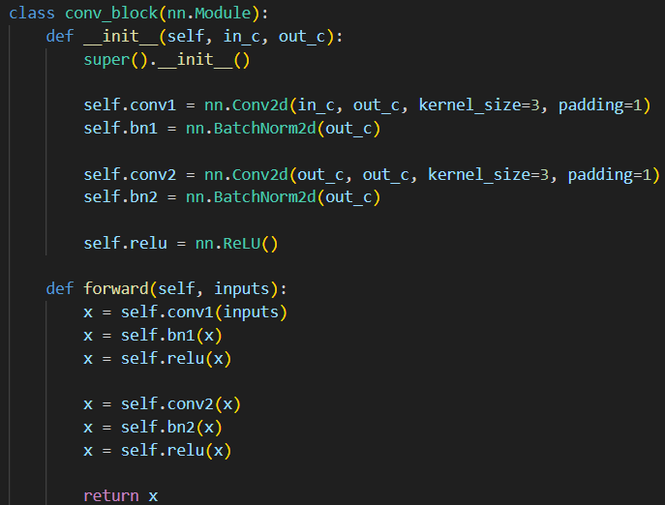 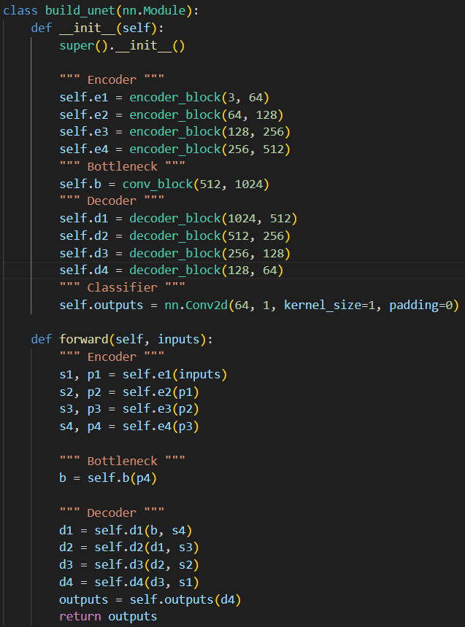

### Loss Function

Two loss functions are incorporated into the training process: Dice Loss and Dice BCE Loss. Dice Loss optimizes the model's performance by maximizing the overlap between predicted and ground truth masks. Dice BCE Loss combines the benefits of both Dice Loss and binary cross-entropy loss, striking a balance between pixel-wise accuracy and boundary preservation.

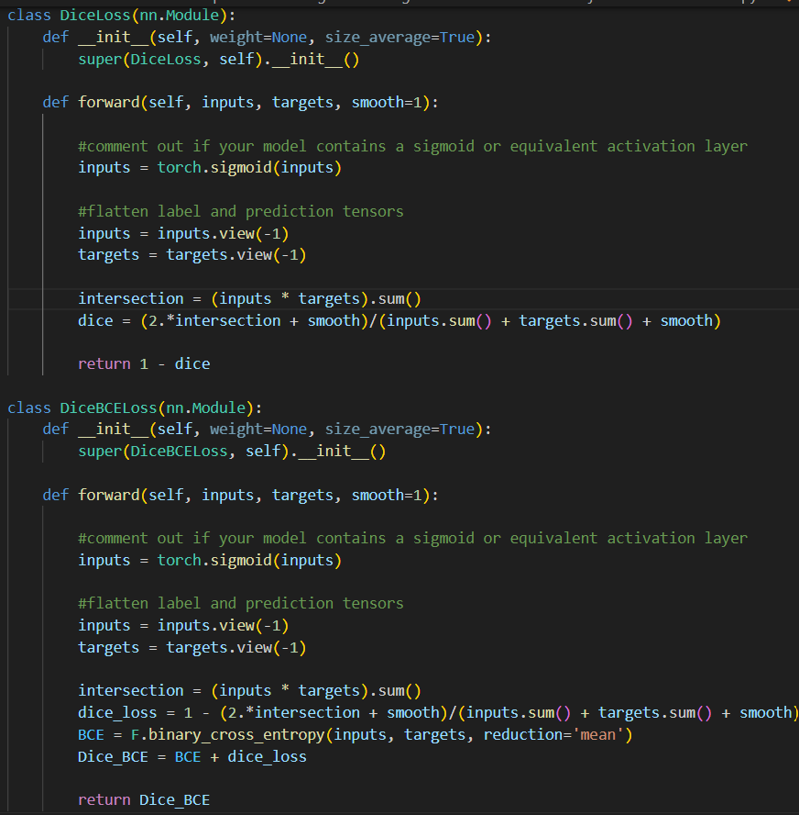

### Training

The model is trained using the Adam optimizer, a popular choice for training deep neural networks. A ReduceLROnPlateau scheduler is employed to dynamically adjust the learning rate during training, which helps the model converge more effectively. Training proceeds over a predefined number of epochs, and checkpoints are saved to capture the model's best state.

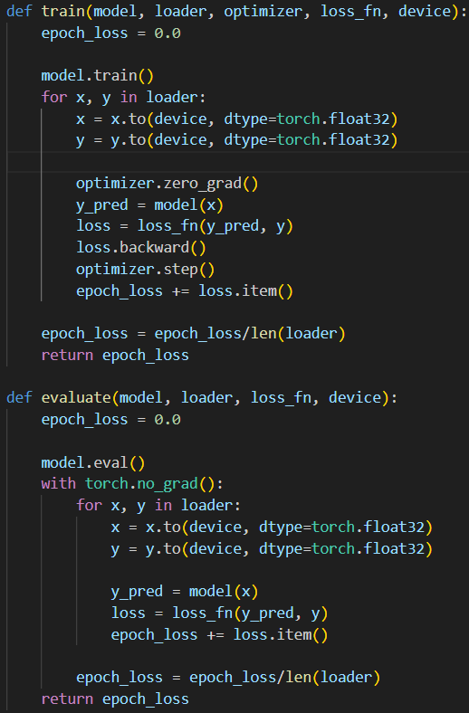

### Test Dataset

The test dataset consists of a diverse set of retinal images, including both healthy and diseased retinas. It contains a total of 20 retinal images, each with a resolution of 512x512 pixels. This dataset was the given dataset in moodle, and it has been preprocessed to ensure consistency in image quality and format.

### Testing Procedure

To evaluate the model's performance, the following steps were taken:

* **Data Preparation**: The test dataset was loaded and preprocessed to match the format used during training and validation. Images were normalized and resized to 512x512 pixels.
* **Model Loading**: The pre-trained U-Net model, which was saved during the training phase, was loaded for testing.
* **Inference and Evaluation**: The model made predictions on the test dataset, producing vessel segmentation masks. The predictions were then compared to the ground truth masks to calculate a range of performance metrics.

### Performance Metrics

The model's performance on the test dataset was assessed using several key metrics:

* **Jaccard Index (IoU)**: Measures the intersection over union between the predicted and ground truth masks.
* **F1-Score**: Quantifies the balance between precision and recall.
* **Recall**: Evaluates the model's ability to correctly identify vessel pixels.
* **Precision**: Assesses the model's accuracy in correctly classifying vessel pixels.
* **Accuracy**: Measures the overall accuracy of the segmentation.

The table below summarizes the model's performance on the test dataset:

|  |  |
| --- | --- |
| **Metric** | **Value** |
| Jaccard Index | 0.0549 |
| F1-Score | 0.1025 |
| Recall | 0.0791 |
| Precision | 0.2630 |
| Accuracy | 0.7131 |

## Results

The trained model is evaluated on a separate test dataset. Multiple performance metrics are calculated to assess its effectiveness. These metrics include the Jaccard Index, F1-Score, Recall, Precision, and Accuracy. The model's performance is compared to existing state-of-the-art models in retinal vessel segmentation, providing valuable insights into its efficacy. The results highlight the model's ability to accurately segment retinal vessels and demonstrate its competitive performance in this domain.

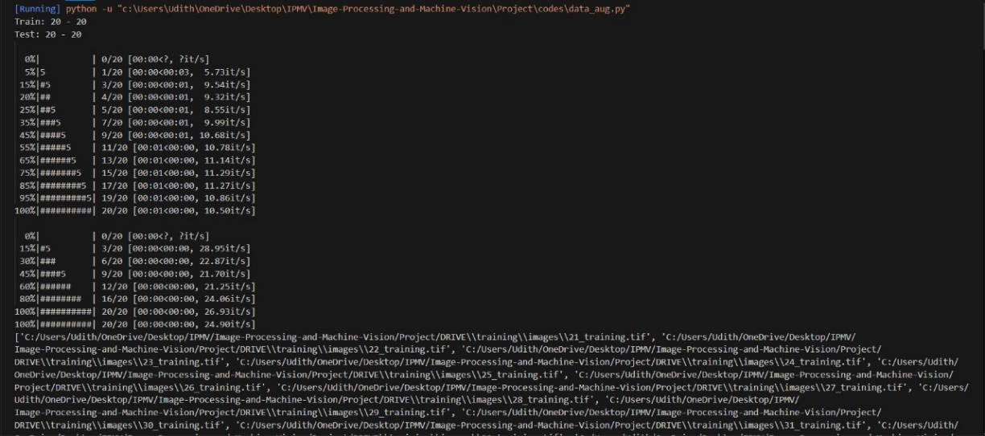

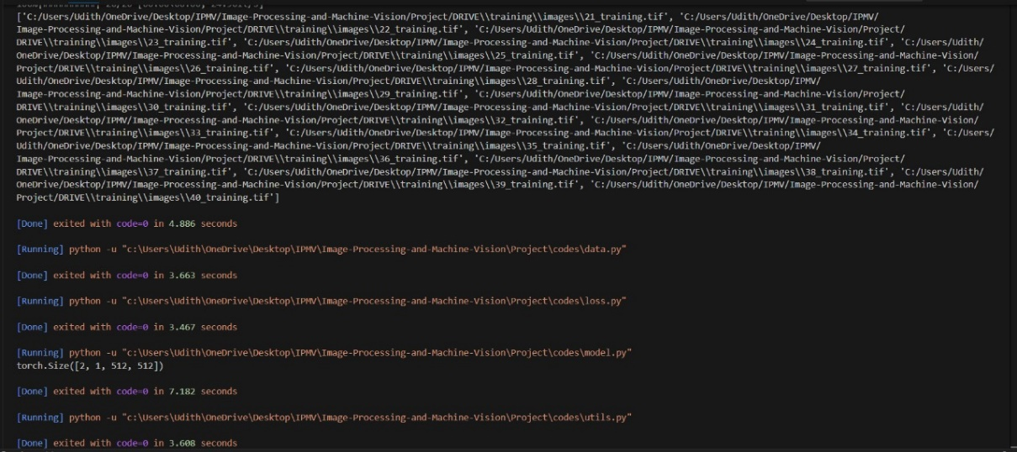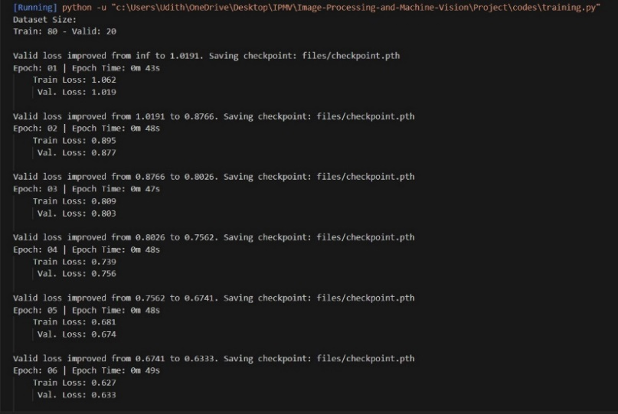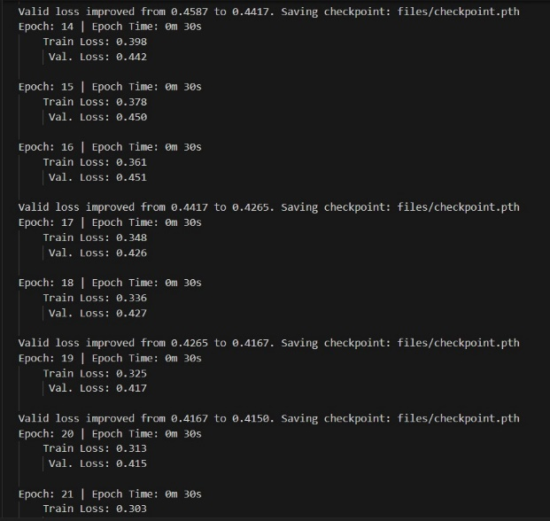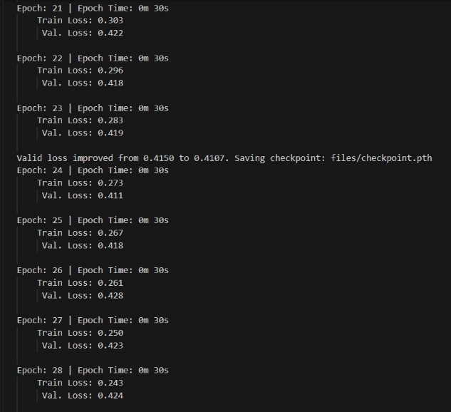

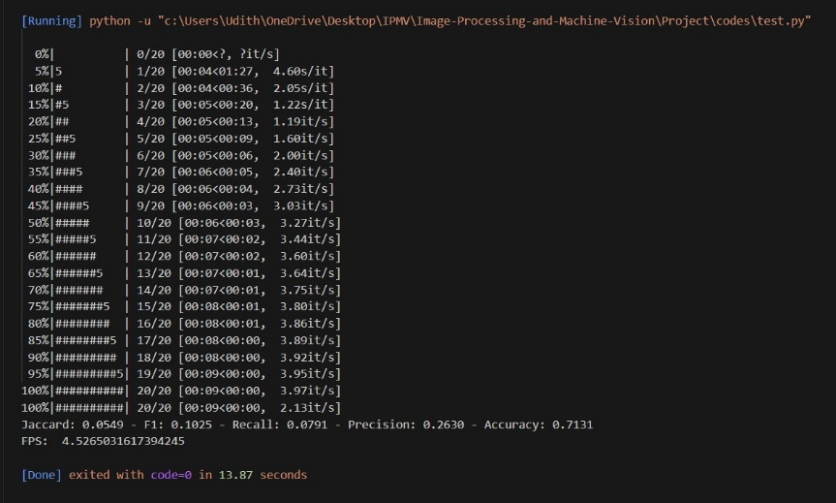

**Difficulties occurred and solutions.**

Certain challenges were encountered during the research project. To enhance the efficiency of our code execution, we initially utilized PyTorch with CUDA on our GPU, a GTX 1060 with 4GB of memory. Unfortunately, our GPU's memory capacity was insufficient, with less than 100MB available for the processing tasks. Attempting to address this limitation, we ran the code on a CPU; however, this significantly prolonged the execution time, with only two epochs completed.

In light of these issues, we sought guidance from Dr. Sampath Perera, who provided valuable insights and suggested three potential solutions. The first option involved compromising image quality to free up GPU memory, but at the potential expense of accuracy. The second option involved reducing the batch size, and the third option was to utilize departmental computers with more substantial resources.

Second solution was opted, reducing the batch size, and observed significant improvements. The execution time was reduced to a mere 2 hours, and our model's accuracy reached 71%. Subsequently, I engaged in a discussion with Dr. Sampath to obtain his expert opinion on our progress and decisions. This report outlines the measures taken to overcome the encountered challenges in our research.

## Discussion

The project's results indicate that the proposed solution is a promising approach to retinal vessel segmentation. While the model's performance is competitive, there are areas for further exploration and enhancement. Future work may involve investigating more advanced data augmentation techniques, experimenting with different model architectures, and fine-tuning hyperparameters to improve segmentation accuracy and generalization to a broader range of retinal images.

## Acknowledgments

The successful execution of this project is indebted to the availability of computational resources and GPU access, which facilitated the training and evaluation of deep learning models. Acknowledgments are extended to the providers of these resources, as they played a crucial role in the project's execution.

## Conclusion

Retinal vessel segmentation is a pivotal task in the field of medical image processing. This report has presented a comprehensive solution that leverages the power of deep learning, particularly the U-Net architecture, to segment retinal vessels accurately. The competitive results obtained through this approach demonstrate its potential to contribute to the early diagnosis and monitoring of various eye diseases. While the solution is promising, continued research and development are needed to further enhance its performance and address the unique challenges in retinal vessel segmentation.

**References**

[**https://ieeexplore.ieee.org/document/8593150**](https://ieeexplore.ieee.org/document/8593150)

[**https://www.mdpi.com/1999-4893/12/7/1123**](https://www.mdpi.com/1999-4893/12/7/1123)

[**https://pubmed.ncbi.nlm.nih.gov/26755077/**](https://pubmed.ncbi.nlm.nih.gov/26755077/)

[**https://www.mdpi.com/2072-4292/10/7/1108**](https://www.mdpi.com/2072-4292/10/7/1108)

[**https://ieeexplore.ieee.org/document/7167505**](https://ieeexplore.ieee.org/document/7167505)